Welcome, Zhenlong Primary School
- Management>
- International Education >
- Sister School Partnerships

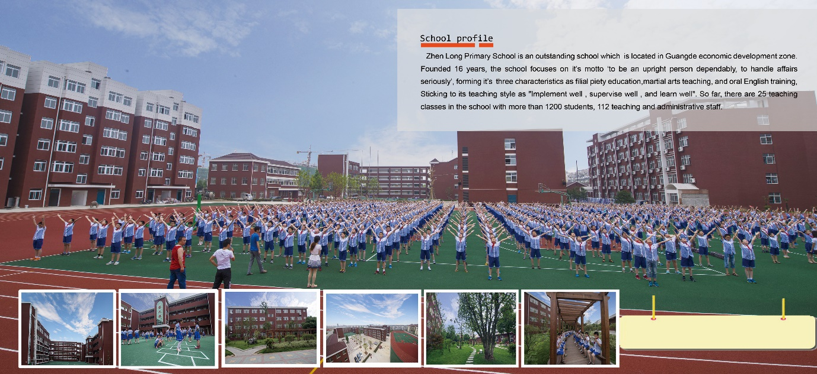
No.1 Wenzheng Road , economic zone , Guangde,Xuanchen,Anhui 242200 , Anhui , China
w: Not available
|ph: 0086 0563 6013070

Key Contacts

Mr Chen Zhen
Principal
E: 228660525@qq.com
P: 0086 0563 13865315888
Mr Hong Liu
vice principal
E: 40129635@qq.com
P: 0086 0563 13856350721

About my School

Primary language used in school:
Chinese (People's Republic of China)

Foreign languages taught in school:
English
School type:
Primary (Years Prep-6) , Government
Is mixed or single-sex:
Mixed
Number of students:
1001-2000

Specialisation:
Foreign Languages; Information Technology; Sport; Outdoor Education

Special needs support:
School specialises in students with special needs

Collaboration Options

Project Preference:
Sister School Partnership (school to school partnership)
Partnership Country:
Australia
Partnership Outcome:
We hope that through the establishment of this relationship to promote cultural communication between each otherAnd bring the students more teaching resources, cultural impact, we hope would help them have a significant effect in primary school six years and even a lifetime .
Preferred Partnership Activities:
Class to class email; Curriculum projects; Social media; Student visits; Teacher exchange; Teacher visits; Video communication
Preferred contact method:
Email
Profile Active / Inactive
Active

Terms and Conditions

I have read and agreed to the Terms and Conditions
Schools Connect

