Welcome, Taoyuan Municipal Happy Elementary School
- Management>
- International Education >
- Sister School Partnerships

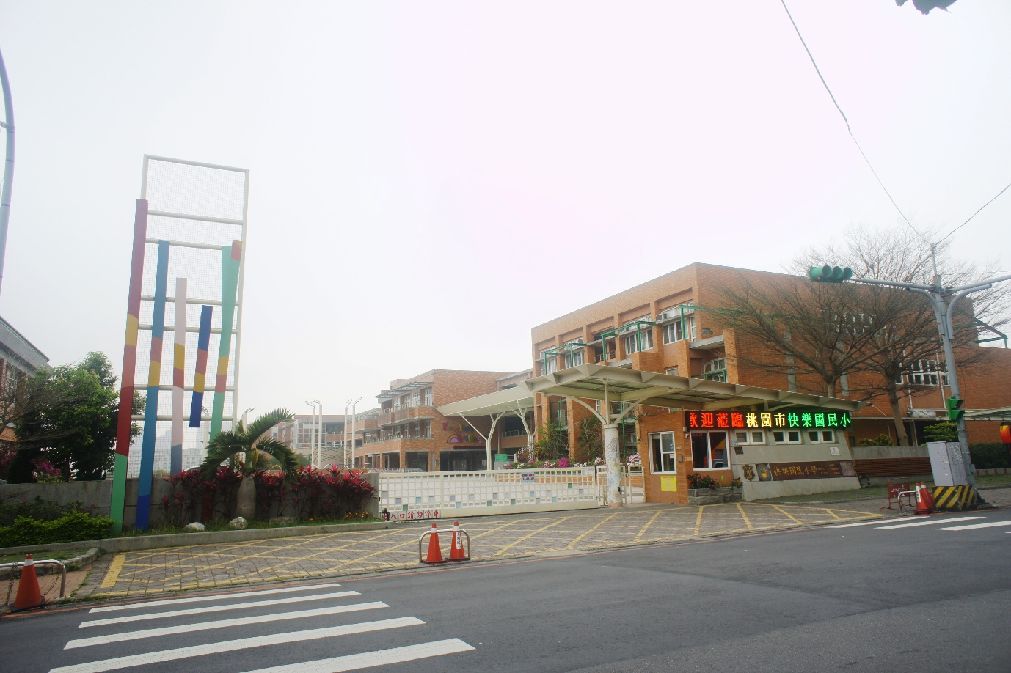
No.789 Dayou Rd. , Taoyuan Dist. , Taoyuan City 33052 , None , Taiwan
w: The more you learn, the happier you get.
|ph: 886 03 3580001

Key Contacts

Mrs Chien-Ching Chu
Principal
E: head@mail.happy.tyc.edu.tw
P: 886 03 3580001
Mrs Stephanie Tseng
Administrative Assistant, Office of International Affairs
E: t142@mail.happy.tyc.edu.tw
P: 886 03 3580001

About my School

Primary language used in school:
Chinese (Taiwan)

Foreign languages taught in school:
English
School type:
Secondary (Years 7-12) , Government
Is mixed or single-sex:
Mixed
Number of students:
501-1000

Specialisation:
Foreign Languages

Special needs support:
Yes, some of our students have special needs

Collaboration Options

Project Preference:
Sister School Partnership and Project Collaboration
Partnership Country:
Australia
Partnership Outcome:
Taoyuan Municipal Happy Elementary School is looking at developing a long-term working relationship with public primary schools, in Australia. We look forward to sharing with you some of our teaching and cultural experiences, from Taiwan.
We are eager to have an effective sister school partnership with you. Our objective is to prepare students as active citizens, with a global outlook. For this purpose, we would like to come over and visit your school. We are also planning to send some of our students to Australia, for homestay with an Australian family.
Preferred Partnership Activities:
Class to class email; Curriculum projects; School blog; Social media; Student visits; Teacher exchange; Teacher visits; Video communication
Type of collaboration:
English; The humanities - geography; The humanities - history; Mathematics; Languages
Preferred year level:
Year 6 (11 years old)); Year 7 (12 years old)
Preferred project length:
Up to 4 weeks
Preferred starting date:
15 / 11 / 2,017
Project Outcome:
Preferred contact method:
Email; Phone; Video-conferencing
Preferred Project Activities:
Class to class email; Curriculum projects; School blog; Social media; Student visits; Teacher exchange; Teacher visits; Video communication
Profile Active / Inactive
Active

Terms and Conditions

I have read and agreed to the Terms and Conditions
Schools Connect

