Welcome, Lysterfield Primary School
- Management>
- International Education >
- Sister School Partnerships

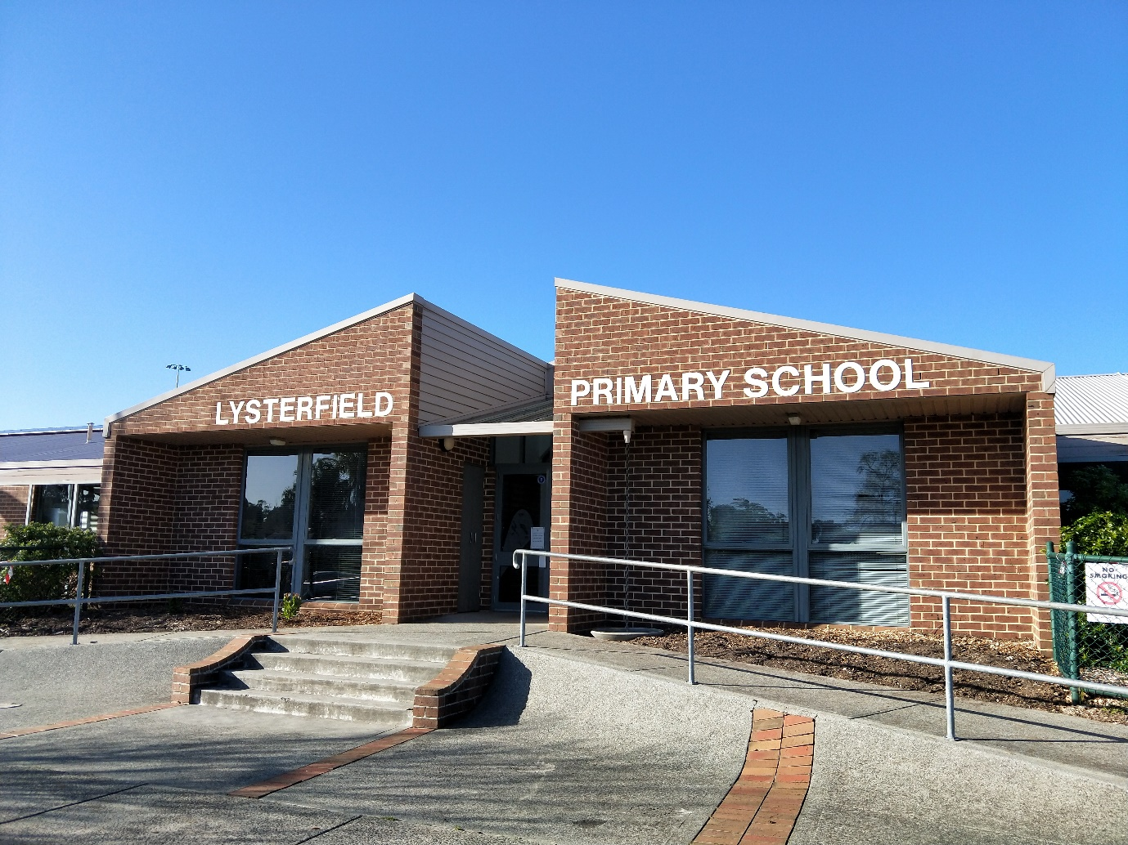
Bellfield Drive , Lysterfield , Melbourne 3156 , Victoria , Australia
w: http://www.lysterps.vic.edu.au
|ph: 61 3 97527953

Key Contacts

Mr Kendra Parker
Principal
E: parker.kendra.h@edumail.vic.gov.au
P: 61 3 97527953
Mr Likai Lin
Chinese Teacher
E: lin.likai.l@edumail.vic.gov.au
P: 61 3 97527953

About my School

Primary language used in school:
English

Foreign languages taught in school:
Chinese, Mandarin
School type:
Primary (Years Prep-6) , Government
Is mixed or single-sex:
Mixed
Number of students:
501-1000

Specialisation:
Foreign Languages; Music; Arts; Sport

Special needs support:
Yes, some of our students have special needs

Collaboration Options

Project Preference:
Sister School Partnership (school to school partnership)
Partnership Country:
China
Partnership Outcome:
Our school started the Mandarin program in 2017 and it has been progressively introduced to Foundation to Year 6 students. We are very interested in finding and establishing a long-term partnership with a primary school in China. We are aiming to increase our students' perspectives of the world and also enhance their language learning through this partnership. Taking our students to China and inviting Chinese students to come and visit would also be our future goals.
Preferred Partnership Activities:
Class to class email; School blog; Student visits; Teacher visits; Video communication
Preferred contact method:
Email
Profile Active / Inactive
Active

Terms and Conditions

I have read and agreed to the Terms and Conditions
Schools Connect

