Welcome, Hae-un-dae Girls’ Middle School
- Management>
- International Education >
- Sister School Partnerships

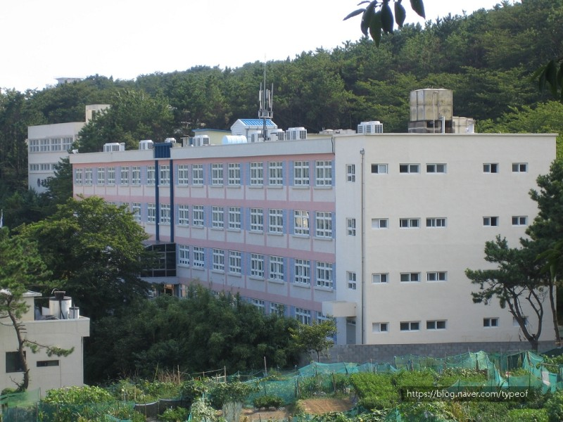
- 25, 85beon-gil, Woo-dong 1ro, Hau-un-dae gu , Busan, South Korea
- 해운대여자중학교 (busanedu.net)
|ph: 82 51 746 2115

Key Contacts

Mr Lee (Ji Soo Lee)
Vice Principal
P: 82 51 743 2920
Mrs Park (Mi Yeon Park)
English teacher who takes charge of Sister-School-Partnership
E: grace7473@gmail.com
P: 82 51 746 1083

About my School

Primary language used in school:
Korean
Foreign languages taught in school:
English, Chinese
School type:
Secondary (Years 7-9)
Only Girls
Number of students:
630-650
Specialisation:
Foreign Languages, Students’ Club Activities
Special needs support:
No, our school does not cater for special needs

Collaboration Options

Project Preference:
Sister School Partnership (school to school partnership)
Partnership Country:
Australia
Partnership Outcome:
We would like to have a language and culture exchange program every year. Your students will participate in Korean school classes with Korean students. They will enjoy various Korean school subjects and activities and learn Korean cultures. They will have a tour around Busan and other areas near Busan. I also hope my students can visit your school and take part in your school classes and learn your cultures. Each school takes turns to visit the foreign school every other year.0
Preferred Partnership Activities:
Students can communicate online before their visit and then they visit each other to experience different school life and culture.
Preferred contact method:
Email
Profile Active / Inactive
Active

Terms and Conditions

I have read and agreed to the Terms and Conditions
Schools Connect

