Arrival Support Form – Melbourne Airport

Important information for schools
- Please complete and return the Arrival Support Form to is.arrivals@education.vic.gov.au within 2 working days of receiving the Flight Details Form.
- When welcoming a student at the airport, it is essential that the school representative wears/carries some form of school identification (e.g., school badge, school ID, school sign).

Important information for education agents
- Please ensure that the student receives this form no later than 10 business days prior to their arrival date.
- Please advise the student to call or text the emergency contacts listed below if they miss their flight, have late connections or will not arrive at Melbourne Airport at the planned time.

Student details
Student name:
International Student ID:

Airport welcome details
Host school:
Name of school representative welcoming student:
School representative mobile no.:
Physical description of the school representative who will meet the student:

(Please attach a photo of the person who will meet the student if possible)
Airport meeting point: | Melbourne Airport International Arrivals  Look for the sign MELBOURNE pictured below - school staff will be located nearby.  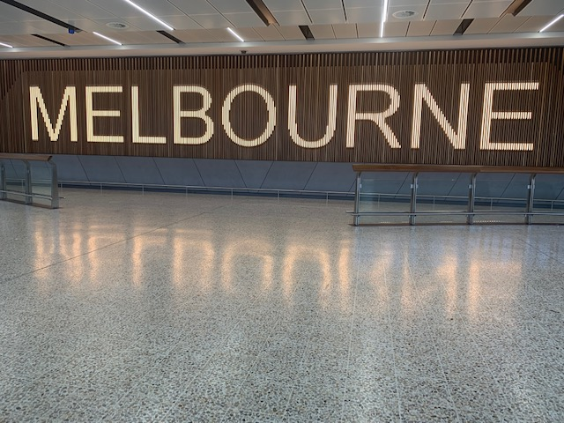

Secondary school contact
International Student Coordinator (or secondary host school contact):

Flight details
Flight number:
Airline:
Arrival date (dd/mm/yy):
Arrival time (am/pm)
Arrival terminal: |  | Terminal #:

Emergency contact details
(In the case of an emergency, please contact the following persons)
Title | Name | Mobile
- International Student Coordinator:
- School Principal:
- Department representative: | Manager, Admissions & Agent Unit | +61 497 971 295

