# Updating contact information in CASES21

Schools must maintain up-to-date contact information for students, parents, emergency contacts, and homestay hosts (if applicable), including name, address, email and mobile phone numbers. In addition to ongoing updates, schools must ensure each international student completes and signs the [International Student Contact Information Form](https://www.study.vic.gov.au/Shared%20Documents/en/School_Toolkit/ISP_Student_Contact_Confirmation_Form.docx) in the presence of the International Student Coordinator every six months (ideally at the start of Term 1 and Term 3).

Schools must update any changes in contact information in CASES21 within 3 working days of becoming aware of any change. Instructions on how to update CASES21 are outlined below.

## Primary family

### Australian residential address and contact information (Homestay, Third Party or relative residing in Australia)

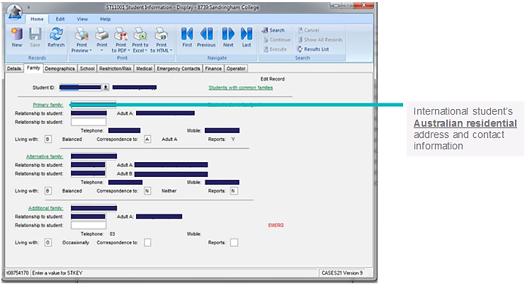

## Alternative family

### Parent (home country) address and contact information, including an email address

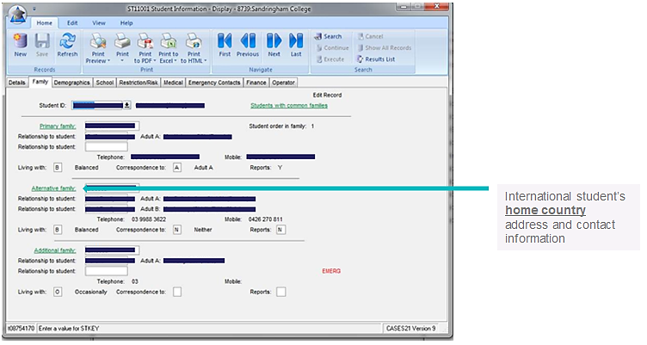

## Alternative family (cont’d) – parent’s email address

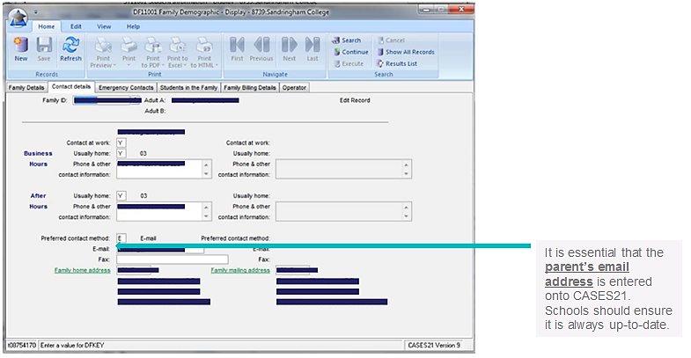

## Student Mobile and Student email address

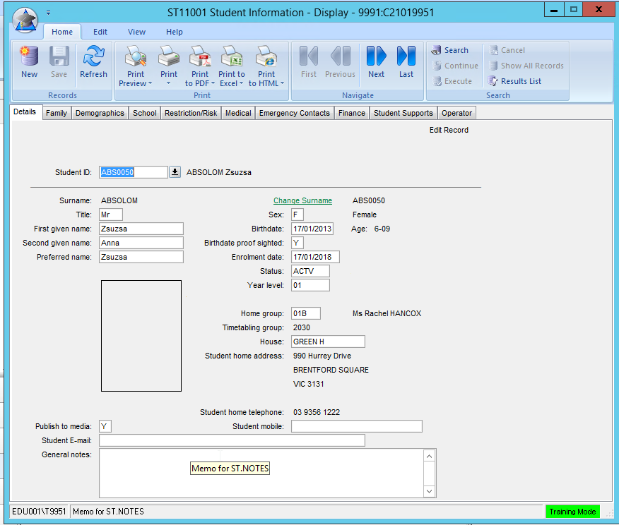

It is essential that the **student’s email and mobile number** are entered on CASES21. Schools should ensure that it is always up to date.