ISP Student Arrival and Orientation Procedure

Purpose
To outline the steps involved in an international student’s arrival and orientation, including key roles and responsibilities in relation to supporting international students to adjust to study and life in Australia.
This procedure is intended for DET (IED) and school staff and should be read in conjunction with the ISP Student Support Policy and ISP Student Orientation Checklist. It outlines the roles and responsibilities of DET (IED) and school staff to:
- prepare for a student’s arrival
- welcome and safely greet the student
- accompany the student to their homestay residence
- deliver an orientation program
- provide ongoing support following a student’s arrival and orientation.

Roles and responsibilities

Executive Director, IED
- Approve policies, procedures and guidance materials (such as pre-arrival information, brochures, forms and templates) issued by DET (IED) in relation to arrivals and orientation.

DET (IED)
- Ensure published guidance materials (such as brochures, forms and templates) are relevant and accurate.
- Provide pre-arrival information (including the ISP International Student Pre-departure Guide) to the student, parents and education agents once enrolment has been confirmed.
- Provide advice and support to school staff to assist them to implement this procedure and the related policy.
- Maintain accurate and up-to-date records consistent with the ISP Record Keeping Procedural Guidelines.

School staff
- Organise greeting student at the airport and transportation to homestay (where applicable) upon their initial arrival in Australia.
- Develop and coordinate the delivery of an age and culturally appropriate orientation program for international students.
- Notify DET (IED) of changes to student’s enrolment.
- Provide ongoing support to students to adjust to study and life in Australia.
- Ensure orientation information is regularly reviewed.
- Maintain accurate and up-to-date records consistent with the ISP Record Keeping Procedural Guidelines.

School Principal
- Approve the school’s orientation program.
- Oversee the ongoing support provided to international students.

Process

Student Arrival
This procedure is aligned to the ISP Student Support Policy, and the steps below are represented in the ISP Student Arrival Flowchart (Appendix 1).
- DET (IED) provides pre-arrival information (including the ISP International Student Pre-departure Guide) to the student, via parent/education agent once enrolment has been confirmed.
- DET (IED) request and receive the Flight Details Form from the student, via the parent/education agent, and share this information with the school. DET (IED) also retain this information on the student record.
- School staff complete and provide to DET (IED):
  - ISP Arrival Support Form (Melbourne or Avalon) for offshore students (arriving to Australia from overseas)
  - ISP Homestay Transfer Support Form for onshore students (have previously arrived in Australia and are transferring into the care of DET (IED)).
  - ISP Homestay Profile Form for all students.
DET (IED) then provide this information to the student, via parent/education agent.
- DET (IED) liaises with the students, via parent/education agent prior to arrival to confirm arrangements and answer queries.
- School staff organise the collection of the international student from the airport (if applicable) and transportation of the student to their homestay.
- School staff notify DET (IED) when the student has arrived safely and has been transported to their homestay.
- School staff provide the student with updated school emergency contract details if required and confirm the student’s and parent contact details.
- School staff notify DET (IED) of any changes to the international student’s enrolment and DET (IED) advises the Commonwealth Government, using Provider Registration and International Student Management System (PRISMS), in line with the ISP Variation to Enrolment Procedure.

Student Orientation
This procedure is aligned to the ISP Student Support Policy, and the steps below are represented in the ISP Student Orientation Flowchart (Appendix 2).
- DET (IED) develops and provides to guidance materials to schools to assist in the development of orientation programs for international students.
- School staff prepare age and culturally appropriate orientation programs for international students, including information about:
  - Introduction to the school*
    - School hours and routines
    - Term dates and holiday dates
    - Facilities and resources
    - Acceptable behaviours (for example Student Code of Conduct or Student Engagement Policy)
    - School requirements for course attendance and progress including ISP Attendance Policy and ISP Course Progress Policy
    - Orientation to local area and transport
    - Who to contact in an emergency (including issuing an ISP Student Safety Card)
    - How to seek assistance for and report incidents that significantly impact the student’s wellbeing, including critical incidents or child abuse
    - General information on safety and awareness relevant to life in Australia, for example sun and water safety
  - Introduction to the ISP*
    - Key DET (IED) policies and procedures including the ISP Complaints and Appeals Policy
    - Translated Written Agreement, including terms and conditions
    - Translated Student Visa Conditions
    - Homestay Responsibility Agreement and ISP Homestay Profile Form (where applicable)
  - Support services available to assist students
    - Adjusting to study and life in Australia
    - Managing general or personal circumstances that are adversely affecting their education in Australia
    - English language proficiency
    - Study and academic achievement
  - Health services
  - Legal services
  - Homestay (where applicable)
  - Money and banking
  - Australian laws, customs and culture
  - Actions international students can take to enhance their personal security and safety
  - Services international students can access for information on their employment rights and conditions, and how to resolve workplace issues, such as through the Fair Work Ombudsman, consistent with their student visa conditions.
* Orientation program components marked with an asterisk must be delivered on the student’s first day of school.

- The school principal approves the orientation program.
- School staff meet the international student on their first day of school and complete the following:
  - introduce the student to school staff including the school principal and support staff (for example the School Nurse, School Counsellor, Wellbeing Coordinator and Pathways/Careers Coordinator)
  - match student with a local student (buddy) and introduce to fellow students
  - undertake a tour of the school and supply map of the school
  - provide student timetable, student diary, student ID card, ISP student safety card, book list and uniform information (where applicable)
  - deliver mandatory components of the orientation program delivered on a student’s first day
- Within the first two weeks of an international student starting school, school staff:
  - deliver remainder of orientation program
  - complete ISP Student Orientation Checklist
  - finalise year level placement and notify DET (IED), if required
  - finalise subject selection and inform parent/education agent, if required.
- School staff communicate with the student regularly regarding their wellbeing and adjustment to study and life in Australia. This includes scheduling follow up sessions within the first two months of the student’s arrival to discuss any issues the student is facing.
- School staff raise any issues discussed with the international student and ensure appropriate support or intervention is provided by:
  - referring to the relevant DET (IED) policy or procedure
  - assisting students to access support services, if required, including access to learning support services as required by the student and their learning needs
  - Escalating to the School Principal where the issue is not resolved, or if required under the relevant policy.

Legislation
- Education Services and Overseas Students Act 2000 (Cth)
- National Code of Practice for Providers of Education and Training to Overseas Students 2018 (Cth)

Related documents
- ISP Student Support Policy
- ISP Student Orientation Checklist
- ISP Student Safety Card Procedure
- ISP Complaints and Appeals Policy
- ISP Record Keeping Procedural Guidelines
- ISP International Student Pre-departure Guide
- Flight Details Form
- ISP Arrival Support Form (Melbourne)
- ISP Arrival Support Form (Avalon)
- ISP Homestay Transfer Support Form
- ISP Homestay Profile Form

Definitions
- DET (IED) – Department of Education and Training – International Education Division. IED is the division in DET that administers the International Student Program in Victorian government schools. IED is not a separate entity to DET. DET is the CRICOS registered provider.
- Education agents are accredited by DET (IED) to recruit students for an ISP course.
- International students (students) for the purpose of this policy are defined as students participating in the ISP under a subclass 500 Student – Schools visa.
- International Student Program (ISP) for the purpose of this policy is defined as DET’s ISP administered by the DET International Education Division (IED).
- DET (IED) staff includes the Executive Officers, managers and employees (full time, part time, ongoing, fixed term, casual and contractor) of DET who work directly or indirectly with the ISP. This excludes school staff.
- Parent refers to the parent(s) or legal guardian(s) of an international student.
- School means any Victorian government school accredited by DET (IED) to deliver an international student program.
- School enrolment cap refers to the maximum number of international students that can be enrolled at any one time in an accredited school.
- School staff are employees of schools, for example – International Student Coordinator, Homestay Coordinator, Head of Department, Deputy Principal, and Principal.

Contact
For further information, please contact the DET (IED) School Support Team on + 61 3 7022 1000.

Maintenance officer
Portfolio Director, International Education
International Education Division
Department of Education and Training.
Level 28, 80 Collins Street, Melbourne, Victoria 3000
Email: international@education.vic.gov.au
Phone: +61 3 7022 1000

Authorised
Executive Director, International Education Division

Date of authorisation: 11/10/2022
Review frequency: This procedure will be reviewed at minimum annually or when any changes arise impacting its currency, including legislative or regulation change.

Appendix 1 – ISP Student Arrival Flowchart
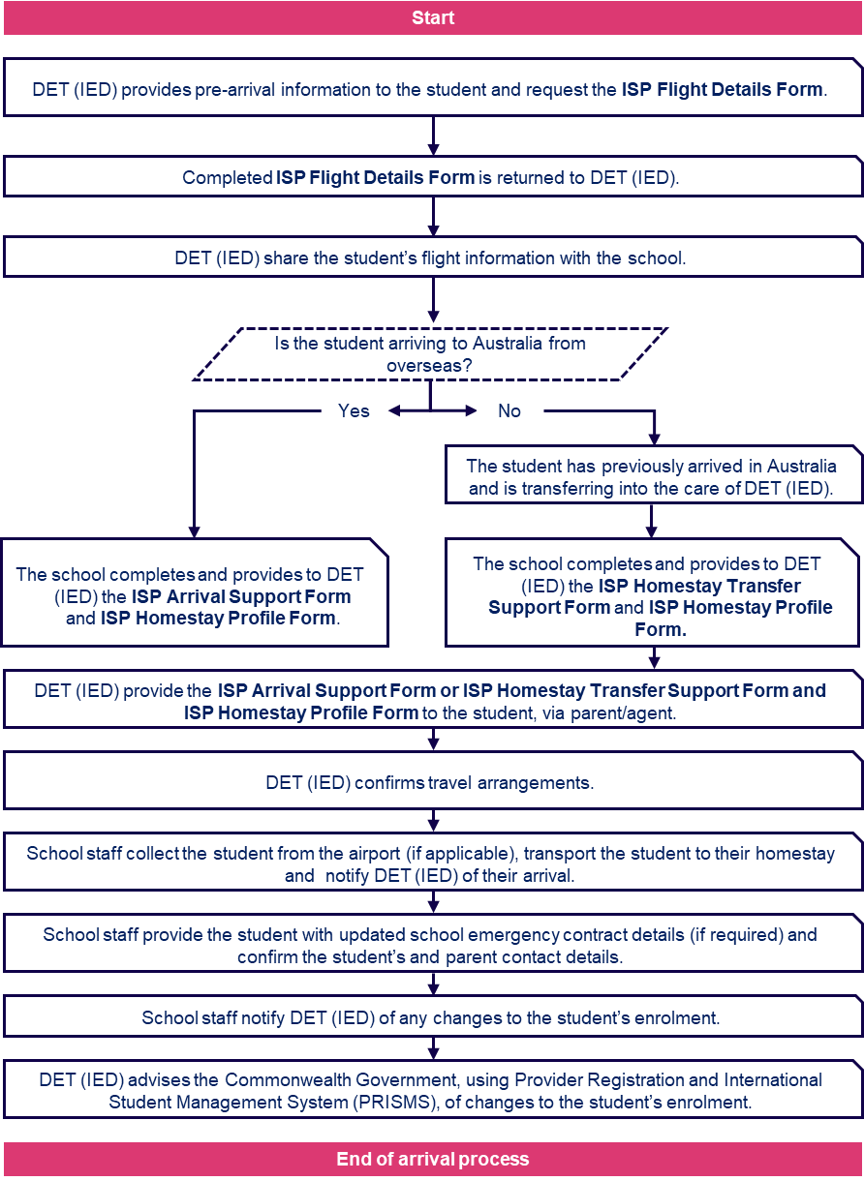

Appendix 2 – ISP Student Orientation Flowchart

