Welcome, St Patrick's Primary School
- Management>
- International Education >
- Sister School Partnerships

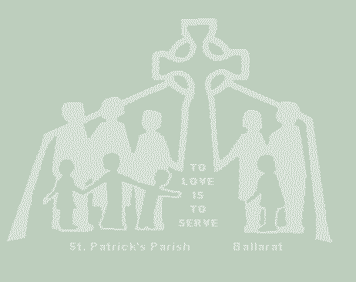
119 Drummond Street South , Ballarat , Ballarat 3350 , Victoria , Australia
w: St Patrick's Primary School Ballarat
|ph: 61 03 53327680

The project that is intended culminates in celebrating Indonesian Independence Day.
Leading up to this celebration would see the two schools working togther to:
- Develop a greater understanding of the histories of the two countries
- Develop an appreciation and respect for the significance of each country's celebrations
- Increase language skills through emailing and joint project work focusing on questions and responses about each other's country's
- Sharing of culturally significant traditons associated with their country's celebrations, e.g. dances, food, games.

Key Contacts

Mr Mark Hogbin
Principal
E: mhogbin@spballarat.catholic.edu.au
P: 61 03 53327680
Mr Catherine Whelan
Deputy Principal
E: cwhelan@spballarat.catholic.edu.au
P: 61 03 53327680

About my School

Primary language used in school:
English

Foreign languages taught in school:
Indonesian
School type:
Primary (Years Prep-6) , Non-Government
Is mixed or single-sex:
Mixed
Number of students:
101-250

Specialisation:
Foreign Languages; Music; Information Technology; Sport; Maths and Science

Special needs support:
Yes, some of our students have special needs

Collaboration Options

Project Preference:
Sister School Partnership and Project Collaboration
Partnership Country:
Indonesia
Partnership Outcome:
At St Patrick's Primary School, we are excited to begin a long-term relationship with an Indonesian school with the purpose of initiating and maintaining reciprocal educational activities.
This will hopefully provide students and teachers with the opportunity to:
- enhance cultural understandings and skills to communicate across cultures.
- explore new cultures, experience new learnings and develop qualities to become active global citizens.
- develop language skills
- facilitate and maintain school-to-school and community-to-community involvement
Preferred Partnership Activities:
Class to class email; Curriculum projects; Video communication
Type of collaboration:
English; The arts - dance; The humanities - geography; The humanities - history; Languages
Preferred year level:
Year Prep (5 years old); Year 1 (6 years old); Year 2 (7 years old); Year 3 (7 years old); Year 4 (9 years old); Year 5 (10 years old); Year 6 (11 years old))
Preferred project length:
Up to 10 weeks
Preferred starting date:
15 / 7 / 2,019
Project Outcome:
The project that is intended culminates in celebrating Indonesian Independence Day.
Leading up to this celebration would see the two schools working togther to:
- Develop a greater understanding of the histories of the two countries
- Develop an appreciation and respect for the significance of each country's celebrations
- Increase language skills through emailing and joint project work focusing on questions and responses about each other's country's
- Sharing of culturally significant traditons associated with their country's celebrations, e.g. dances, food, games.
Preferred contact method:
Email; Phone; Video-conferencing
Preferred Project Activities:
Class to class email; Curriculum projects; Video communication
Profile Active / Inactive
Active

Terms and Conditions

I have read and agreed to the Terms and Conditions

