Welcome, King’s Kids Secondary School
- Management>
- International Education >
- Sister School Partnerships

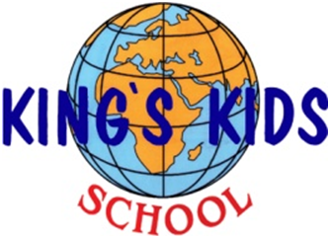
Ikh Toiruu 49 11th khoroolol , 6th khoroo Sukhbaatar district , Ulaanbaatar 11000 , None , Mongolia
w: school introduction website
|ph: 976 11 99997599

Any project that enhances students' understanding of the International Mindedness and also improve student's communicating skills in English.

Key Contacts

Mrs Khulan Tsenddoo
Principal
E: tokhulan@yahoo.com
P: 976 11 99997599
Mrs Myagmarsuren Jumba
Advisor teacher
E: domiga13@yahoo.com
P: 976 11 99115332

About my School

Primary language used in school:
Mongolian

Foreign languages taught in school:
English
School type:
Secondary (Years 7-12) , Non-Government
Is mixed or single-sex:
Mixed
Number of students:
251-500

Specialisation:
Foreign Languages

Special needs support:
No, our school does not cater for special needs

Collaboration Options

Project Preference:
Sister School Partnership and Project Collaboration
Partnership Country:

Partnership Outcome:
Our school is an English language specialized bilingual school. Starting this academic year of 2017 we are also implementing the International Primary and Middle Year Curriculum. We want to become sister schools with schools in English speaking countries and expand our teachers and students' experience in an international atmosphere.
On the other hand we can offer authentic Mongolian experience in a country of Blue Sky.
Preferred Partnership Activities:
Class to class email; Student visits; Teacher exchange; Video communication
Type of collaboration:
English; The humanities - geography; The humanities - history; Languages
Preferred year level:
Year 1 (6 years old); Year 2 (7 years old); Year 3 (7 years old); Year 4 (9 years old); Year 5 (10 years old); Year 6 (11 years old)); Year 7 (12 years old); Year 8 (13 years old); Year 9 (14 years old); Year 10 (15 years old); Year 11 (16 years old)
Preferred project length:
Up to half a year
Preferred starting date:
1 / 11 / 2,017
Project Outcome:
Any project that enhances students' understanding of the International Mindedness and also improve student's communicating skills in English.
Preferred contact method:
Email
Preferred Project Activities:
Class to class email
Profile Active / Inactive
Active

Terms and Conditions

I have read and agreed to the Terms and Conditions
Schools Connect

