Welcome, Chiben Gakuen Wakayama High School
- Management>
- International Education >
- Sister School Partnerships

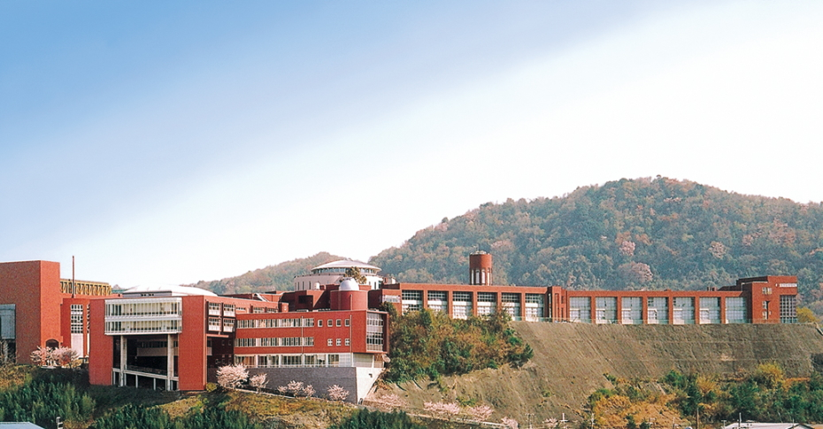
2066-1 - , Fuyuno , Wakayama 640-0392 , Wakayama , Japan
w: http://www.chiben.ac.jp/wakayama/
|ph: 81 6400392 73-479-2811

Key Contacts

Mr Kiyoshi Fujita
Principal
E: kfujita@chiben.ac.jp
P: 81 73 479-2811
Mr Masahito Amatsutsumi
Sister-School-Partnership Manager
E: mamatsutsumi@wakayama.chiben.ac.jp
P: 81 73 479-2811

About my School

Primary language used in school:
Japanese (Japan)

Foreign languages taught in school:
English
School type:
Secondary (Years 7-12) , Non-Government
Is mixed or single-sex:
Mixed
Number of students:
1001-2000

Specialisation:
None

Special needs support:
No, our school does not cater for special needs

Collaboration Options

Project Preference:
Sister School Partnership (school to school partnership)
Partnership Country:
Australia
Partnership Outcome:
We would like to have a student-exchange program every year. You will be highly appreciated if our students, whose number is about twelve, can stay with your students for about two weeks and attend your school events and classes and so on. We will also welcome your students as well.
Preferred Partnership Activities:
Student visits
Preferred contact method:
Email
Profile Active / Inactive
Active

Terms and Conditions

I have read and agreed to the Terms and Conditions
Schools Connect

