Welcome, Beaumaris Secondary College
- Management>
- International Education >
- Sister School Partnerships

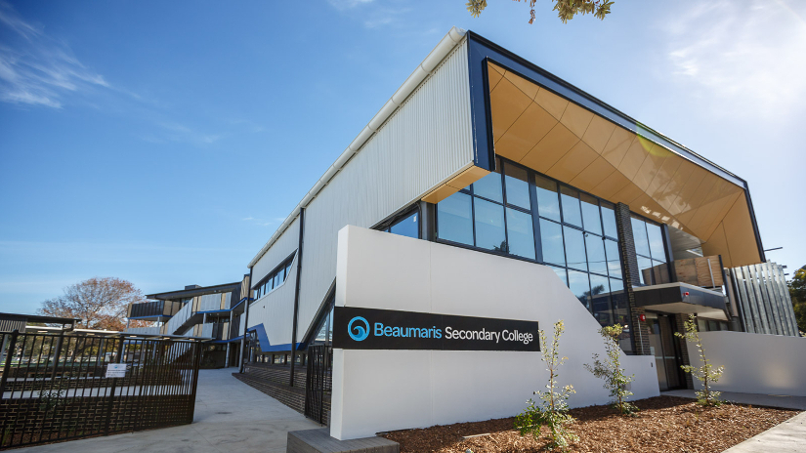
117-135 Reserve Road , Beaumaris , Melbourne 3193 , Victoria , Australia
w: http://www.beaumarissc.vic.edu.au/
|ph: 61 03 85699200

Key Contacts

Ms Debby Chaves
Principal
E: chaves.debby.m@edumail.vic.gov.au
P: 61 3 85699200
Ms Sarah Keating
Leading Teacher
E: keating.sarah.k@edumail.vic.gov.au
P: 61 3 85699200

About my School

Primary language used in school:
English

Foreign languages taught in school:
French; Japanese
School type:
Secondary (Years 7-12) , Government
Is mixed or single-sex:
Mixed
Number of students:
251-500

Specialisation:
Foreign Languages

Special needs support:
Yes, some of our students have special needs

Collaboration Options

Project Preference:
Sister School Partnership (school to school partnership)
Partnership Country:
Japan
Partnership Outcome:
Beaumaris Secondary College prides itself on offering opportunities for students to make real-world connections. The school would endeavour to offer reciprocal exchange opportunities for schools in both France and Japan to allow students to make these valuable and life changing connections and enhance their language abilities.
Preferred Partnership Activities:
Student visits; Teacher exchange
Preferred contact method:
Email
Profile Active / Inactive
Active

Terms and Conditions

I have read and agreed to the Terms and Conditions

